**Circuit Manager MOTS 6134**

**Circuit Manager and Net Provisioning are sunset applications – exact retirement date is unknown at this time.**

**Circuit Manager and Net Provisioning source codes are in the CodeCloud GIT repository*.*** [***https://codecloud.web.att.com/dashboard/***](https://codecloud.web.att.com/dashboard/)

**ATM/FRAME is a networking technology for building virtual circuit paths using the related ATM and FRAME protocols.**

**CM is the database of record for AT&T ATM/FRAME and DSL uses ATM/FRAME in some cases.**

**Circuit Manager reconcile EMS data and Tirks (Trunk Inventory Record Keeper System) data streams and Modifies the Oracle DB.**

**Circuit Manager Users Contact: Kathy Carmody – kc3454 – will help with DB passwords, some general information**

**Current DBAs for CM: Vikrant Supehia (vs0906) as an Primary DBA and Sudarshan Daga (sd721t) as backup DBA**

**Tools used for Circuit Manager:  
 ColdFusion (an HTML development system with many advanced features)**

**Oracle**

**Java**

**Perl**

**shell (bourne/ksh)**

**Unix utilities**

**Special Note: CMI classic merger integration tool also uses the CM servers, Oracle database and Cold Fusion. (mots 19904). Not supported by TechM CM/NetP group**

**Mech IDs used in CM are:  
m84987**

**m45678**

**m58221**

**m58471**

**m77245**

**m95033**

**m28026**

**m28027**

**m28028**

**m28029**

**m28030**

**m31773**

**m31774**

**m31775**

**m31776**

**m31777**

**m40189**

**m70237**

**m80839**

**Additional responsibilities:  
Handle all NCTA (Non compliance** **and Authorization** )  **tracking a issues. There are several non-compliance issues with these applications, because of their age, about 25 years old. You will receive an email notifying you that there is a non-compliance issue, and a link. Follow the link and complete the form, submit it. This is work input only, not support for the application.**

**The link for NCTA is** [**https://ncta.it.att.com/user/documents**](https://ncta.it.att.com/user/documents)**. Emails are sent out whenever a NCTA is about to expire and will require renewal.**

**Disaster Recovery - Application Recovery Coordinator – responsible for acknowledging the successful completion of the annual DR exercise. Another group handles the actual DR exercise.**

**_________________________________________________________________________________________________________**

**Circuit manager home page:** [**http://cm.asi.sbc.com/**](http://cm.asi.sbc.com/)

**Typically only the ATM Frame Relay Login is used. We do not do any network provisioning.**

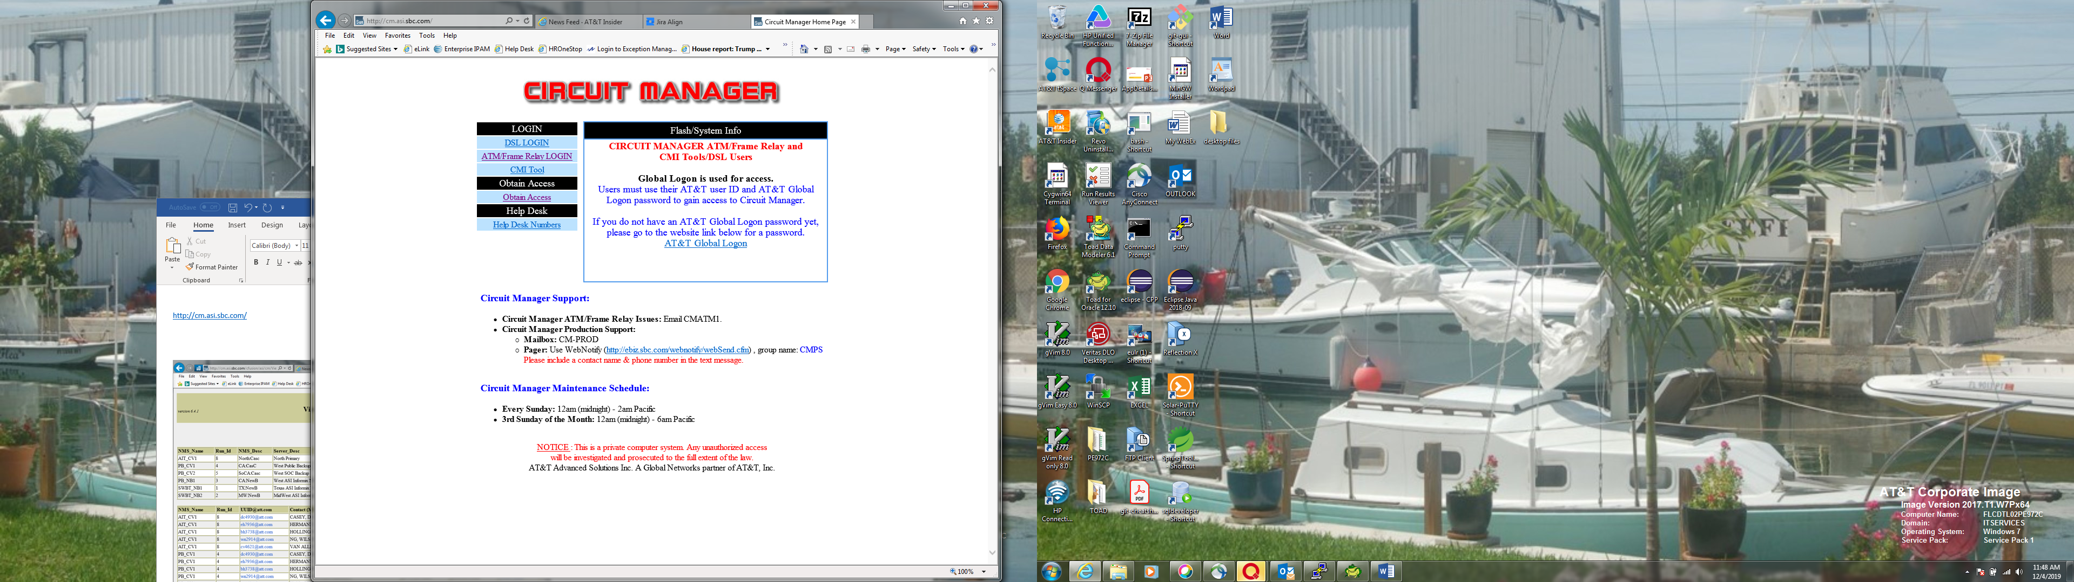

**Selecting ATM takes you to this page:**

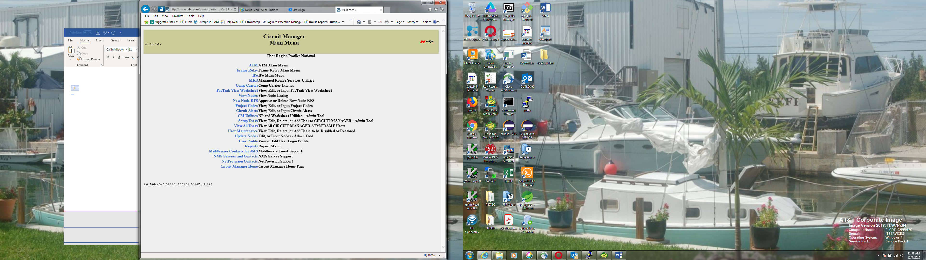

**The most useful of these selections is the NMS Servers and Contacts page:**

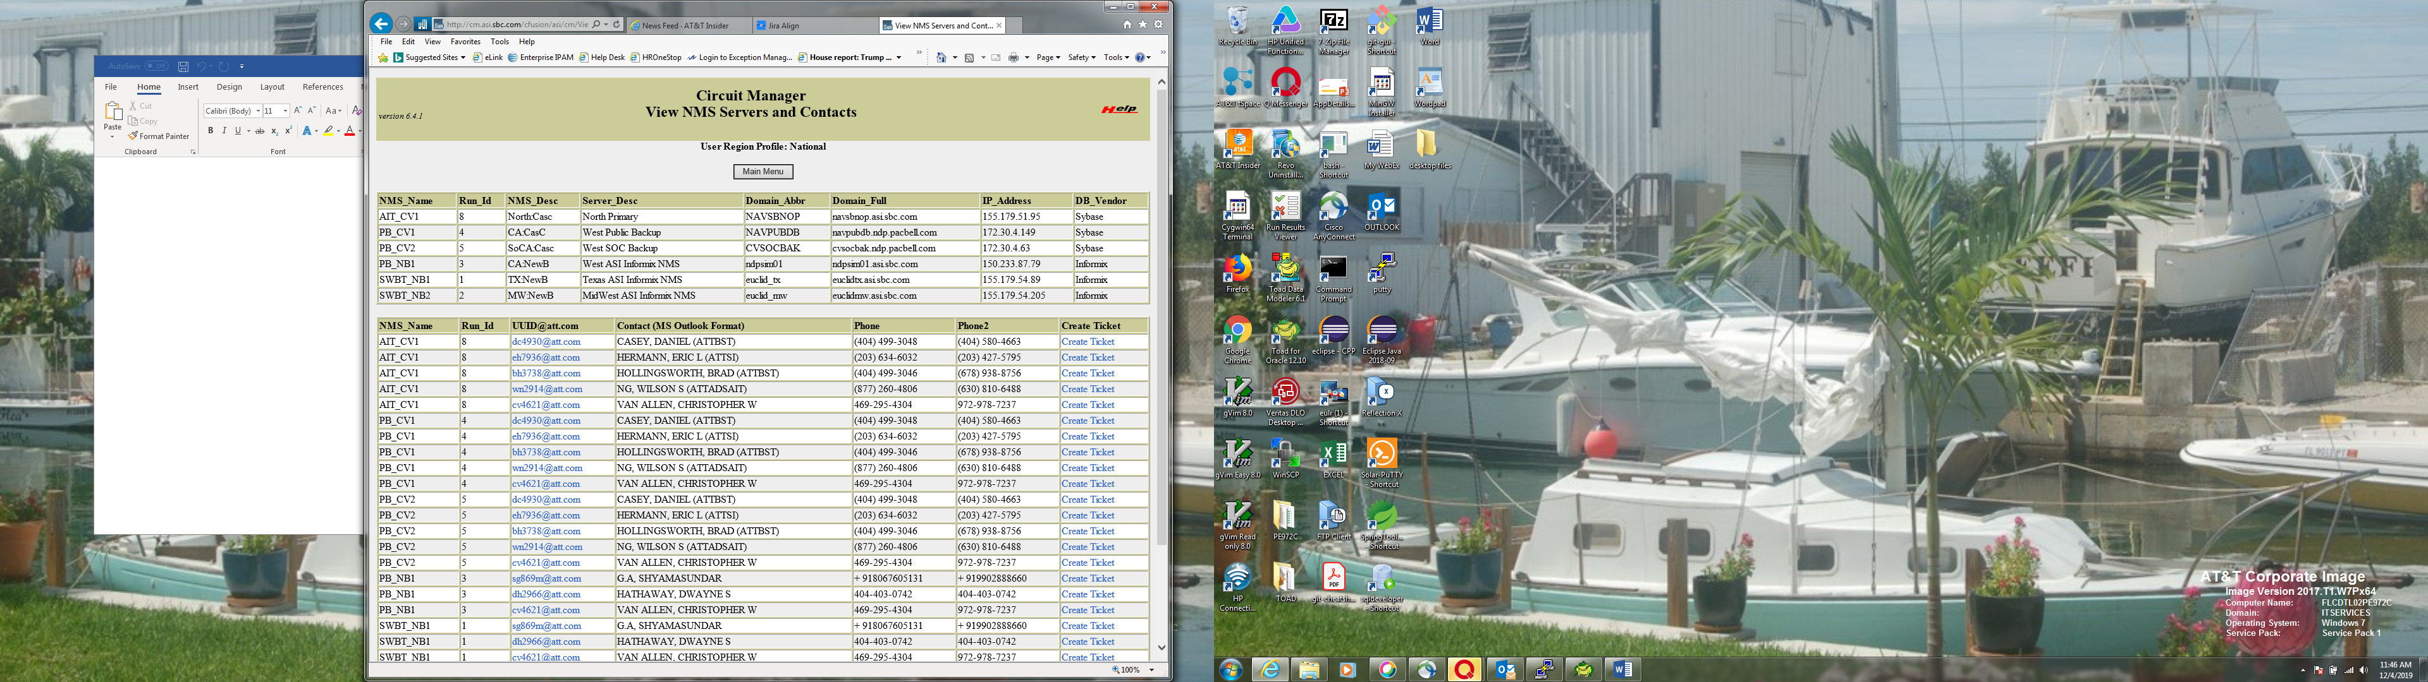

**There are 6 Element Management systems (ems) databases. These are shadow databases, that are loaded daily.**

**There are 3 Sybase databases, and 3 Informix databases.**

**There is a daily script - /appl_atm/tools/ems_data_change_rpt.ksh that checks to see if any changes are detected in updating the ems.**

**It looks for any changes in the last 8 days and if no changes are detected for the last 8 days it sends out an email like the one below.**

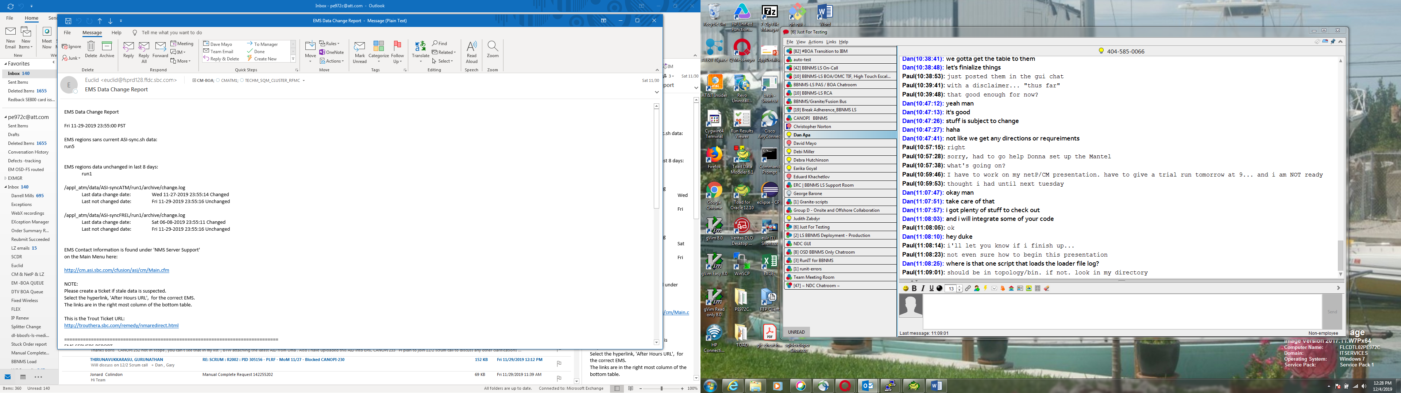

**IF you get an email similar to this one, several days in a row, then you need to open a ticket as per the contacts information page above. The email will give the links needed.**

**Normally after a few days of receiving this kind of email you will receive one like this:**

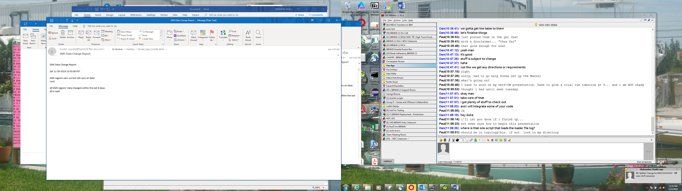

**This email shows that “All EMS regions’ data changed within the last 8 days”. No action is needed. If it doesn’t clear after 8 days, open a ticket according to the contact list above.**

**The servers for circuit Manager *fspcmdb1.ffdc.sbc.com* for production, and *fsdevtst.ffdc.sbc.com* for test (development – though there is NO development team)**

**Take note of the naming convention fs p cmdb1 and fs dev tst…**

**There are 3 users that you can sudo as, adsl, euclid, and www. By far the most commonly used user is Euclid. The directory structure is similar for all three:**

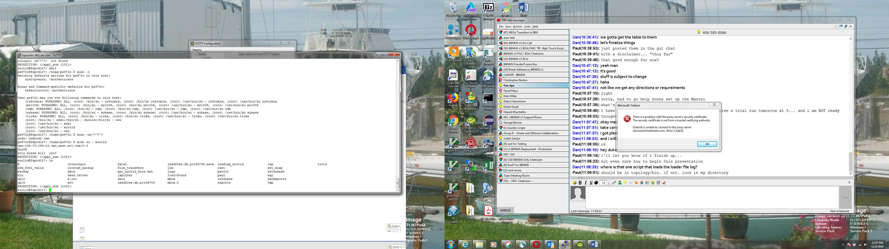

**The tools directory is the most useful.**

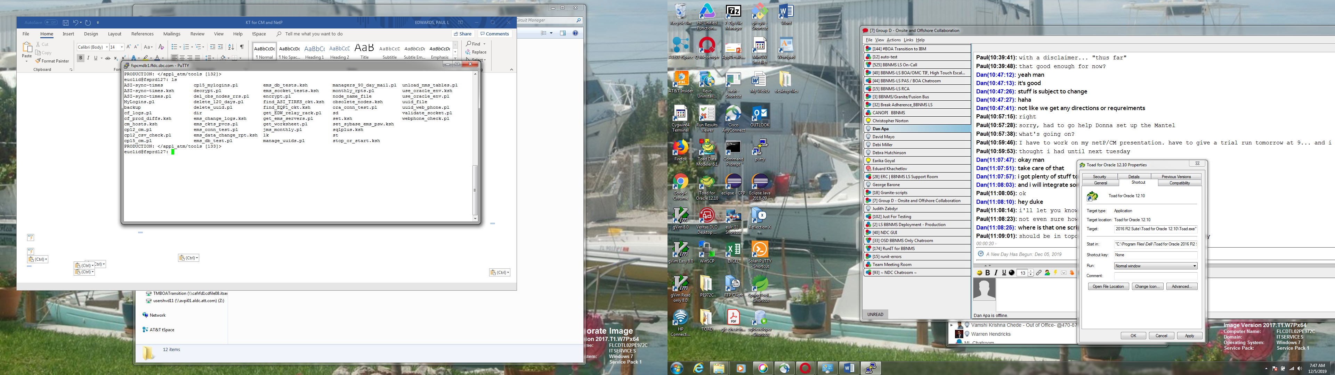

**Of particular importance are the decrypt.pl and encrypt.pl scripts used for password storage and retrieval.**

**There are several useful tools here: *get_ems_servers.pl* returns information on the various ems’s.**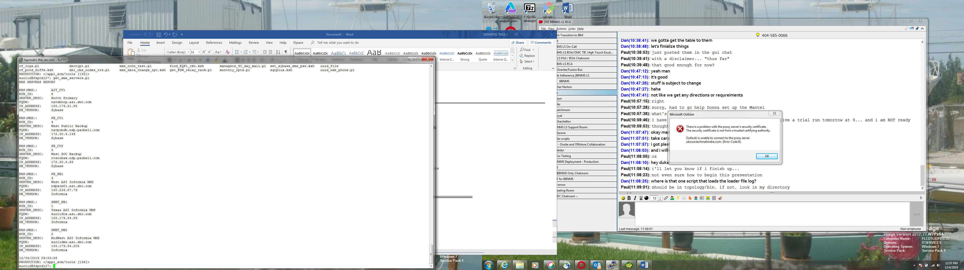

**Another script that is used is *obsolete_nodes.ksh* . Occasionally, as a system is turned down you will get a request to remove the node from the database, and this script will do that for you.**

**The names are suggestive of their purpose, and each script has a description at the head of the file, for example**

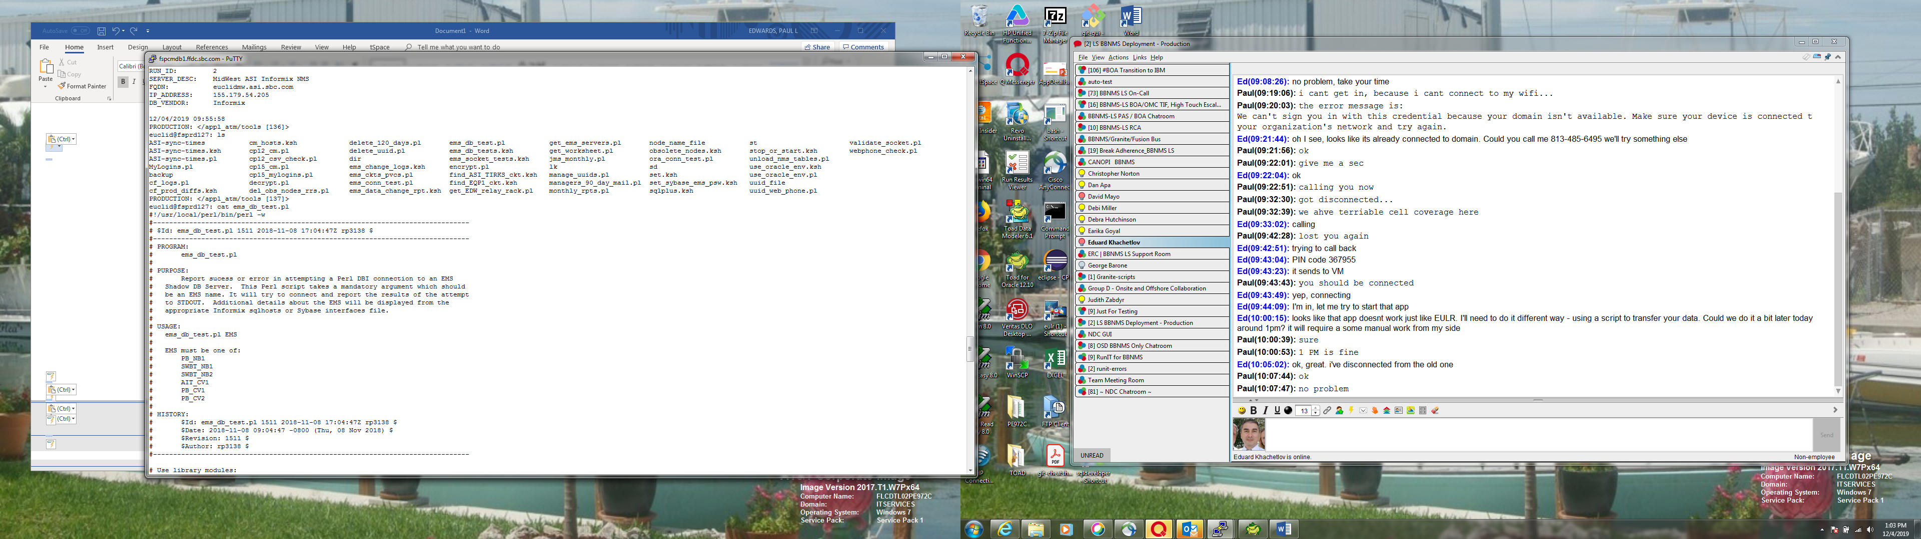

**Quickest way to check the status of Circuit Manager in Production is to go to this web page: *http://cm.asi.sbc.com/cgi-bin/whatsup.cgi***

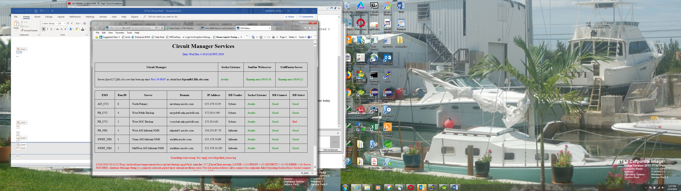

**If this page comes up, the Circuit Manager is working. Note that we have one bad DB select. This is because we are running on an alternate database server while a network configuration is taking place. To make a change like this go to the Circuit Manager Database as user Euclid, change the status form I ( inactive ) to A (active) and vise versa for the server to put into or out of service, respectively. In the case above CVSOCBAK is the server currently being used, the normal server is SOCDB02.**

**Also note that occasionally you will see an error message regarding one of the ems, saying it is unavailable. This is because the master ems db is updating the shadow db. It can be checked again at a later time, and the error will be gone.**

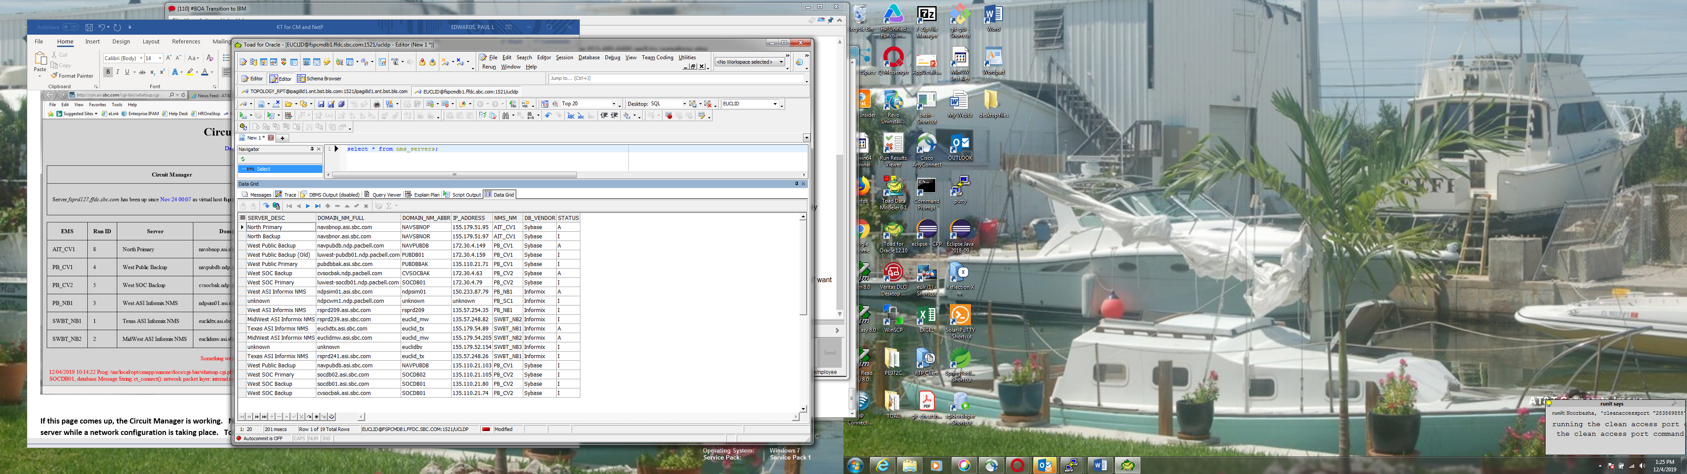

**Quarterly, 1st, 4h, 7th, 10th months, two report needs to be generated. They are FRATM_ATM to FREL_PVCS_rpt and FRATM_FREL_to_ATM_PVCS_rpt.**

**To do this run these queries on the CM database:  
FRATM_FREL_TO_ATM_PVCS_Rpt  
FRATM_ATM_TO_FREL_PVCS_Rpt**

**They are in a file call ATM_and_FREL queries.**

**They are to be sent to Andre Vinel V (va757d) and Tammy L Butler (tb6871) the first of each month it is due.**

**Examples of these reports are on the shared drive. They are excel files.**

**Tirks -** **Topology Interface record keeper system**

**It is a Main Frame based system that pushes Equipment Records -ASCII text files - to CM**

**Nothing has been required of this system in the year I worked on it.**

**Five files are pushed to:** */usr/local/opt/files/tirks*

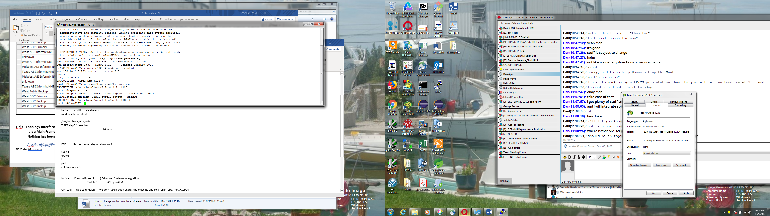

**Lead Free:**

**Shares database information with Circuit Manager.  
occasionally required to change database connection profiles.**

**There is a document called New Lead Free Database Connection in the Circuit Manager shared documents folder.**